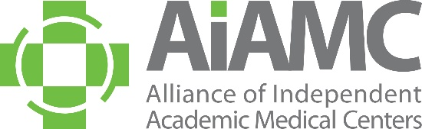

ALLIANCE OF INDEPENDENT
ACADEMIC MEDICAL CENTERS
2025 Annual Meeting
Call for Poster Abstracts

The medical education community is invited to submit abstracts for poster presentation at the AIAMC 2025 Annual Meeting, to be held March 20th – 22nd at the Loews New Orleans Hotel. We encourage you to share this call with colleagues, especially residents who may not typically receive these announcements. Abstracts are due no later than September 16, 2024, and all submitting authors will be notified of the committee’s decision in mid-October.

Criteria for Selection:
- Introduction: clearly articulated context for project or research study, including relevant literature
- Hypothesis/Aim Statement: clearly stated purpose of the project or research study
Methods: clear description of how the project was conducted and/or implemented, with sound and appropriate project design
- Results: clear and unambiguous statement of what changed and how
- Conclusions: implications of the project beyond the local setting
All accepted poster presenters are required to register for the conference*. Please do NOT submit an abstract if your attendance at the Annual Meeting is questionable. Accepted posters will be on display for the entire conference, i.e., from Thursday, March 20th through Saturday, March 22nd. The top abstracts chosen for oral presentation will be presented in a “poster slam” format, followed by a staffed poster display of all posters accepted. Poster presenters are asked to make travel plans accordingly. In accordance with AIAMC policy, all registration fees and travel expenses will be the responsibility of the poster presenter’s home institution. Submitting an abstract is a commitment that, if the abstract is accepted, all poster presenters will attend the 2025 Annual Meeting and conduct sessions at the times assigned.
Poster Session Topics:
Poster content should support the meeting theme of Thriving: The Power of One to Transform as follows:
- Well-Being/Thriving in Today’s Challenging Climate
- The Political Determinants of Health
- Leading From the Heart and Head
- Innovative Approaches to Medical Education/Medical Education as a Vehicle for Change

Poster Display Information:
A suggested PowerPoint template of the poster will be emailed to all selected candidates. The poster board surface must be 42” wide by 30” high (landscape orientation). Poster displays will be assembled on Thursday, March 20th between 8:00 a.m. and 11:00 a.m. They will remain on display throughout the Annual Meeting and National Initiative IX Meeting Four, which concludes midday on Saturday, March 22nd. Any posters not removed at the conclusion of the meetings will be discarded by the hotel staff.
We encourage you to submit an abstract and look forward to seeing you at the meeting!
*Annual Meeting Registration Rates (these are 2024 rates and subject to change):

$800 AIAMC Early Bird AIAMC Member Rate expires 01/15/25
$890 AIAMC Member Rate 01/16/25 – 02/28/25
$700 AIAMC National Initiative IX Participant Rate
$275 AIAMC Member Resident Rate

$475 Non-Member Resident Rate
$995 Non-Member Rate
$450 THURSDAY Only Rate
$250 FRIDAY Only Rate
$300 SATURDAY Only Rate

